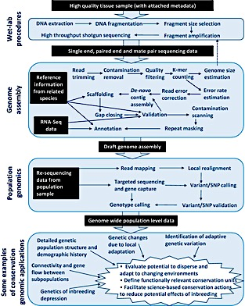



General flow chart for the Illumina TruSeq PCR-free Library Preparation Kit protocol (adapted from TruSeq PCR-free Library Preparation Kit protocol). <https://www.abmgood.com/marketing/knowledge_base/next_generation_sequencing_experimental_design.php#FWGS>

